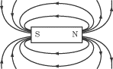C:\Users\user\AppData\Local\Microsoft\Windows\Temporary Internet Files\Content.IE5\LUPVIOEG\MC900238189[1].wmf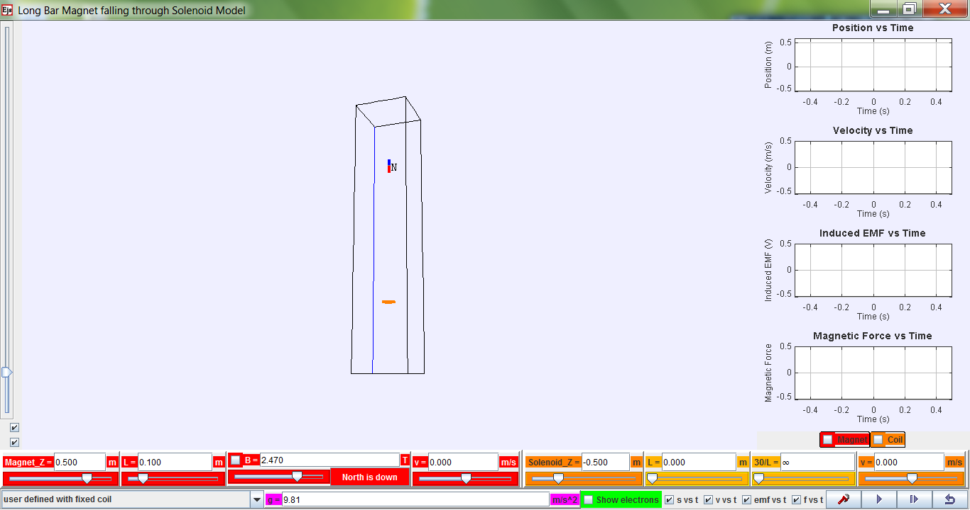

**reverse magnetic polarity**

**show magnetic field lines from magnet**

**show graphs for magnet and/or coil (solenoid)**

N

N

**Bonus! For exploring other scenarios!**

**view from bottom**

**vertical/horizontal**

**Zoom!**

**show motion of electrons in solenoid**

**various graphs!**

**Data analysis!! Really cool tool to help analyse voltage**

****Download the simulation **ejs_FallingMagnet08.jar** from the following link:

**https://dl.dropbox.com/u/44365627/lookangEJSworkspace/export/ejs_FallingMagnet08.jar**

**OR http://tinyurl.com/magfall** QR code on the right. (Needs Java to run.)

**Universal symbols**

 Play / Start

 Play in slow-mo i.e. step-by-step or frame-by-frame simulation

 Reset to default values or factory settings. Click this after playing every simulation and **before changing any settings**.

**Parameters (refer to bottom of the simulation) for exploration**

|  |  |
| --- | --- |
| **Parameter / unit** | **Definition/Meaning** |
| Magnet_Z / m | Initial vertical position (z-axis) of the magnet |
| L / m (in **red** for magnet) | Length of magnet |
| B / T | Magnetic Field Strength of magnet |
| v / m/s (in **red** for magnet) | Initial speed of magnet |
| Solenoid_Z / m | Initial vertical position (z-axis) of the solenoid |
| L / m (in **orange** for solenoid) | Length of the solenoid |
| 30/L | This is meant to be number of turns per unit length.  Due to programming constraints, it is 30 turns/Length set by user. |
| v / m/s (in **orange** for solenoid) | Velocity of solenoid (for exploration of relative velocity. ☺) |

|  |  |
| --- | --- |
| **Scenario A – Falling Magnet through a Solenoid** | |
| Default Settings   |  |  | | --- | --- | | **Parameter / unit** | **Magnitude** | | Magnet_Z / m | 0.500 | | L / m (in **red** for magnet) | 0.100 | | B / T | 2.470 | | v / m/s (in **red** for magnet) | 0.000 | | Solenoid_Z / m | –0.500 | | L / m (in **orange** for solenoid) | 0.000 **🡺 0.500** | | 30/L | ∞ | | v / m/s (in **orange** for solenoid) | 0.000 |  1. **Change solenoid length to 0.500 m.** 2. **Must press Enter key.  Please note that 30/L becomes 60.0 automatically.** 3. **Click on emf vs t (bottom right).** 4. **Click on Coil (bottom right above v).** 5. **Click**  **to run the simulation.** 6. **Copy the simulated graph onto the axes provided.** 7. **Explain the shape of the simulated graph.** | ***t***  ***E*** |
| ……………………………………………………………………………………………………………………… | |
| ……………………………………………………………………………………………………………………… | |
| ……………………………………………………………………………………………………………………… | |
| ……………………………………………………………………………………………………………………… | |
| ……………………………………………………………………………………………………………………… | |
| ……………………………………………………………………………………………………………………… | |
| ……………………………………………………………………………………………………………………… | |