Conceptual Modelling of DC Motor

Name:__________________________( ) Class:__________ Date:________

1. Recap: Kicking Wire Experiment: concepts of the magnetic force generated by the interaction of magnetic field between the current carrying conductor and the permanent magnet.

Click on the following link to gain access to the simulation
(Interaction of magnetic field simulation by MOE/ETD, http://iwant2study.org/lookangejss/05electricitynmagnetism_21electromagnetism/ejss_model_MagneticField2Wirewee4/MagneticField2Wirewee4_Simulation.xhtml)

2. Components of DC motor
Click on the following link to gain access to the simulation
ETD DC motor Simulation: http://iwant2study.org/lookangejss/05electricitynmagnetism_21electromagnetism/ejss_model_DCmotor10wee1/DCmotor10wee1_Simulation.xhtml

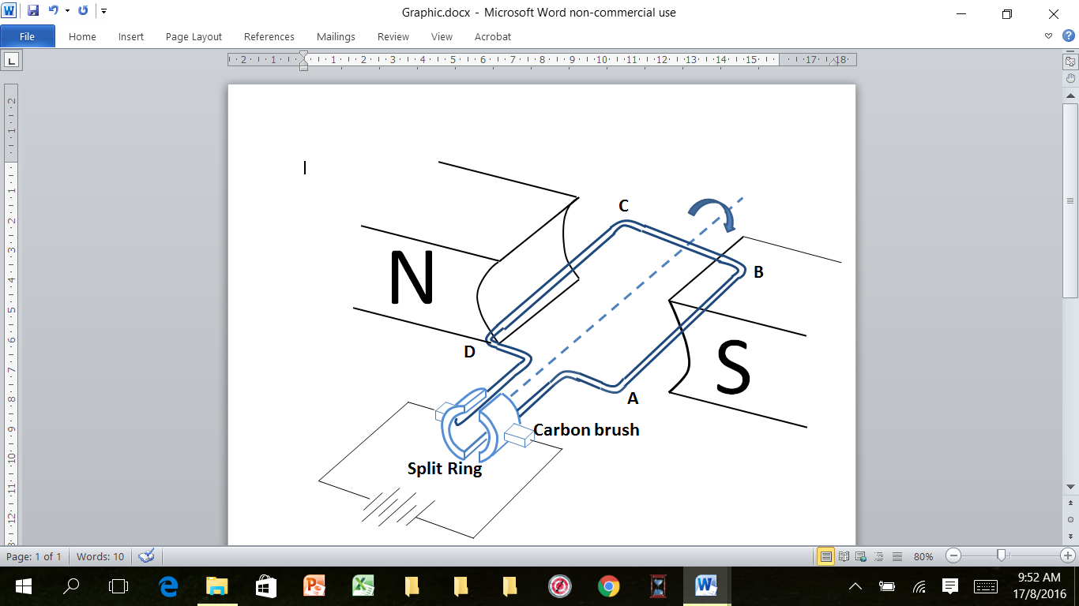

Figure 2: A DC Motor

Activity:
- Identify all components of a DC motor.
- Orientate the coil to a position when the carbon brushes are no longer in contact with the split ring (take note of the limitation of the model).

Please put a tick against the important learning points.

Learning Points | Yes | No
2.1. The single coil with split ring is a combined object (Understand that the coil with the split ring rotates as a unit).
2.2. A permanent magnet to produce a uniform magnetic field.

2.3. The carbon brush material used to provide almost frictionless contact

2.4. The spring loaded design of carbon brushes to provide continuous good electrical contact.
2.5. Aware that carbon brushes will wear out and need to be replaced

2.6. There are two positions in a full revolution where the carbon brushes are no longer in contact with any parts of the split rings.

- How magnetic force is produced in a DC motor?
Magnetic Force

X
Magnetic Force
Y

Figure 3.1: A DC Motor with magnetic forces

Activity:
- Deduction of the direction of magnetic forces. With the aids of demonstration items/simulation, magnetic field pattern of current in the coil and magnetic field pattern of permanent magnet, set up the demo set/simulation according to orientation of Figure 3.1, use superposition method to deduce the direction of the magnetic forces along AB and along CD.
- Use Fleming’s Left hand rule as a short cut to verify the direction of the magnetic forces.
- Orientate the model to position 2 and deduce the direction of magnetic force using Fleming’s Left Hand rule. Repeat process for orientation 3 and 4. (Draw magnetic forces in Figure 3.2)

Position 1 Position 2 Position 3 Position 4

Figure 3.2
Please put a tick against the important learning points.

Learning Points | Yes | No
3.1. A current flowing along AB and CD will produce a concentric magnetic field pattern.
3.2. The direction of magnetic field pattern through a current carrying conductor can be determined using right hand grip rule.
3.3. A permanent magnet will produce a magnetic field.
3.4. A current carrying conductor in the presence of magnetic field from permanent magnet will experience a magnetic force on the conductor/charges in the wire.
3.5. The interaction of the magnetic field from the current flowing through the conductor and the magnetic field from the permanent magnet produced a resultant magnetic force.
3.6. Able to determine the direction of this resultant magnetic force using Fleming’s Left Hand Rule.
3.7. The magnetic force is always perpendicular to the magnetic field from the permanent magnet for position 1 to 3.(see Fig 3.2)
F
F
F

F
F
F

Position 1 Position 2 Position 3 position 4

Figure 3.2

3.8. There is no magnetic force acting on the coil at position 4 because no current passing through the coil. (reason given in 3.9)

3.9. At position 4, carbon brushes are no longer in contact with any parts of the split ring.
3.10. There are two positions in a full revolution (360°) where the carbon brushes are no longer in contact with any parts of the split ring.

4(a) What happens to the motion of the coil at position 4 when there is no magnetic force acting? Explain your answer.

………………………………………………………………………………………………

………………………………………………………………………………………………

………………………………………………………………………………………………

4(b) What happens to the motion of the coil if the polarities of the batteries are reversed? Explain your answer.

………………………………………………………………………………………………

………………………………………………………………………………………………

………………………………………………………………………………………………

………………………………………………………………………………………………

………………………………………………………………………………………………

………………………………………………………………………………………………

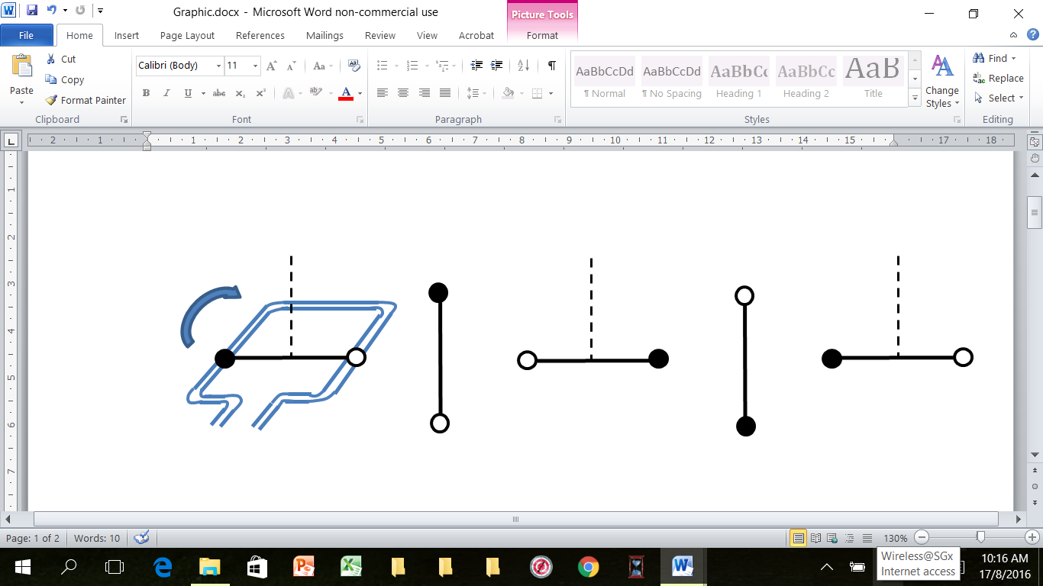
- Activity: Use the model provided to explain why the DC motor is able to turn in the same direction for one complete revolution.
N
S
Position 0°
Position 180°
Position 270°
A
B
C
D
A
D
D
D

A
D
A
Position 360°
A
Position 90°

Figure 5: Shows the position of the coil with respect to the magnetic field.
Draw the direction of magnetic forces on the coils in Figure 5.
Complete the table
Position | 0° | 90° | 180° | 270° | 360°
a. Angle between the magnetic force and magnetic field from permanent magnet | Perpendicular
b.Direction of magnetic forces along AB
c.Direction of magnetic forces along CD
d.Direction of magnetic forces along CB (if any) | Zero
e. Direction of current along AB. e.g. A to B or B to A. | A to B
f. Direction of current along CD. e.g. C to D or D to C | C to D
g. Direction of current along CB. e.g. C to B or B to C. | B to C
Assumption: The magnetic field from permanent magnet is uniform covering the full revolution of the coil.
Please put a tick against the important learning points.
Learning Points | Yes | No
  - The direction of the current along AB & CD is always perpendicular to the magnetic field from the permanent magnet due to the orientation of the coil.
5.2 The magnetic force is always perpendicular to the magnetic field from the permanent magnet if the direction of the current is perpendicular to the magnetic field from the permanent magnet.
  - The magnitude of the magnetic force is constant assuming that the
magnetic field is uniform.
  - When the direction of the current is parallel to the magnetic field from permanent magnet there is no magnetic force acting on the wire e.g. along CB

- Function of split ring.

- Activity: Connect directly the external power source to the ends of the coil bypassing the split ring.

Describe the motion of the coil without the split ring. Can the coil turn continuously in the same direction? Explain your answer.

………………………………………………………………………………………………

………………………………………………………………………………………………

………………………………………………………………………………………………

………………………………………………………………………………………………

- With the split ring in place, describe at which positions the current changes direction. (Use Figure 5)

………………………………………………………………………………………………

………………………………………………………………………………………………

………………………………………………………………………………………………

………………………………………………………………………………………………

Please put a tick against the important learning points.
Learning Points | Yes | No
  - The direction of the current reverses as the carbon brushes crosses from one split ring over to another split ring.
  - As the direction of current changes, the direction of magnetic force also
changes.
  - The change in the direction of forces is such that the moments is in the same direction.

