P09 – Gravitational Field Inquiry-based and Simulation-based Lesson

Pre-requisites
01 × laptop / mobile learning device | http://tinyurl.com/ebookGF
For iOS users: | For Android users:
Points to Note:

- Page numbers are based on iBook, portrait orientation and smallest font size but the page numbers become different when displayed in landscape orientation and with increased font size even on the same iPad.
- Hence, use the screen shot as a guide.
- After keying in values or models, remember to press the return key.

Activity 1 (page 24) – Newton’s Law of Gravitation

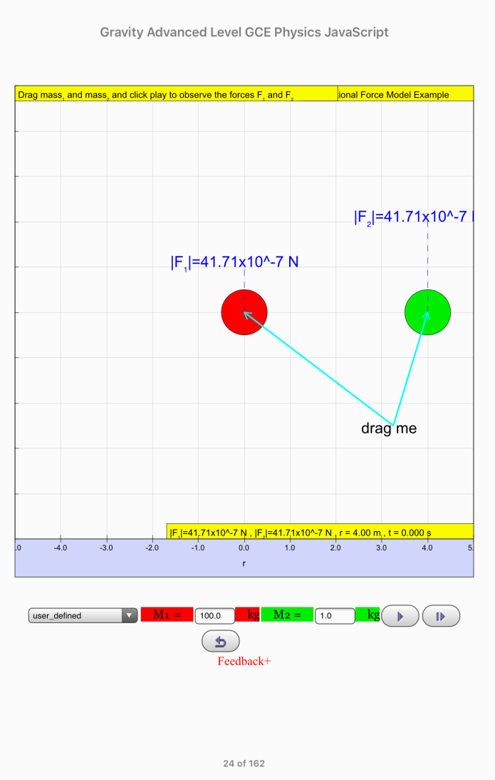 | Thinking Question: When the Earth pulls you down, why do you not pull the Earth up?  - Set M₁ = 100 kg, M₂ = 1.00 kg (press the return key after keying in 1.00) and  r = 4.00 m.  - Click and record your observations.  - Explain the motion and final positions of the two masses.
Activity 2 (page 28) – Binary Stars

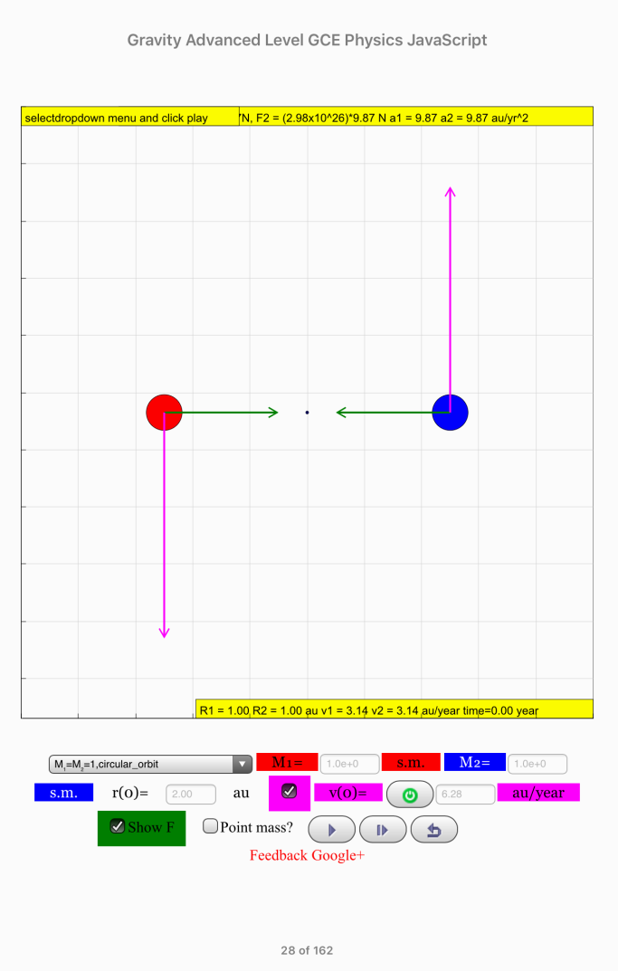 | - Drop-down menu default setting should be “M1=M2=1,circular_orbit”.  - Click and observe the motion, noting the magnitudes of the forces (green arrows) on each mass.  Record your observations.  - Click and now select from the menu “M1=1,M2=0.1,circular_orbit”.  - Click and observe the motion, noting the orbits of the binary stars.  Record your observations.  - You can attempt the example (N09/I/16) on page 29 and use the simulation on page 31 to verify your answer.

Self-Directed Learning (page 32) – Gravitational Field Lines

Activity 3 (page 54) – Gravitational Field Strength

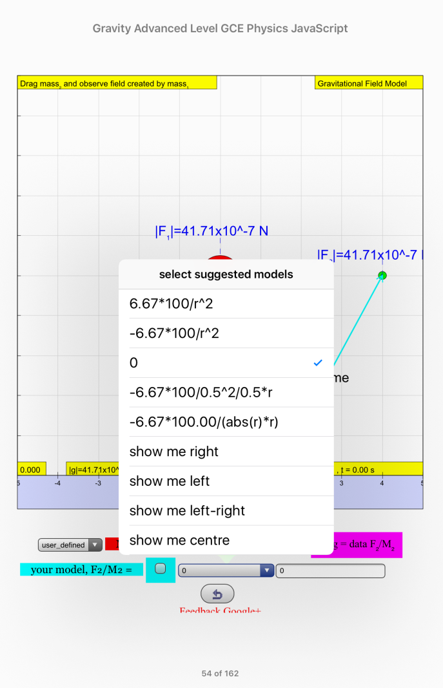 | This activity is to allow students to use mathematical equations or use the drop-down menu for model to propose a mathematically valid equation to represent gravitational field strength.  - Select from the drop-down menu to see how different mathematical models give rise to different graphs.  - Draw the mass to see the correct shape of graph.  - Draw the correct graph below.  g  r  - Flip to page 60 to repeat simulations for different mathematical models to see how g for the Earth varies.

Activity 4 (page 97) – Satellite in Circular Orbit

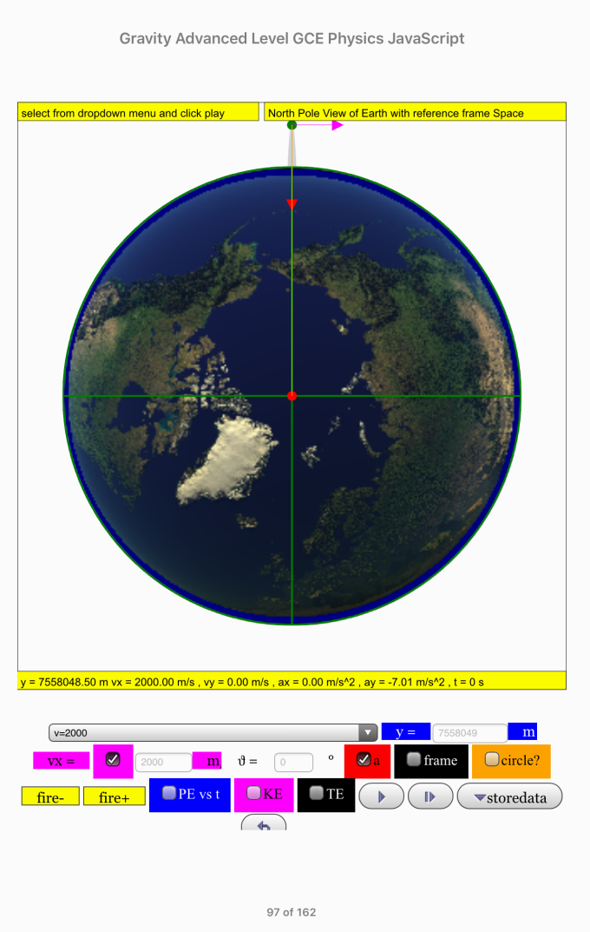 | - Drop-down menu default setting should be v=2000, click and record your observations.  - Click and now select v=4000 from drop-down menu, click and record your observations.  What is different from the previous scenario?  - Click and now select v=8000 from drop-down menu, click and record your observations. What happens now?  - Explain why satellites can remain in orbits and not fall down to the Earth.  - Click and now select v=10000 from drop-down menu, click and record your observations. What happens now?

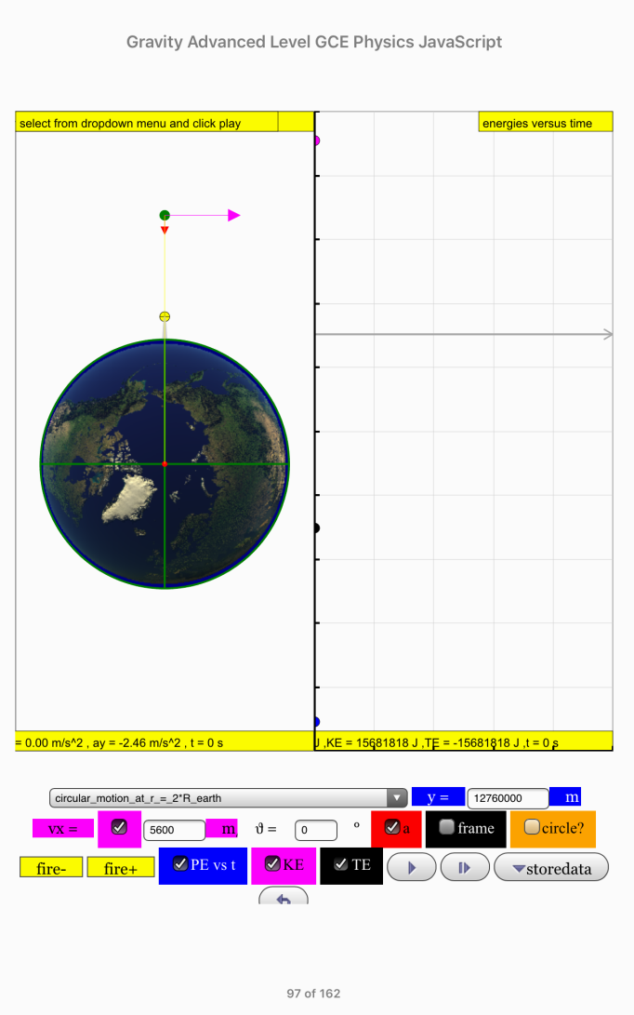 | - Tick the checkboxes for PE, KE and TE to view the potential energy (PE), kinetic energy (KE) and total energy (TE) of the satellite.  - Select “circular_motion_at_r_=_2*R_earth” from the drop-down menu.  - Click and observe the graphs.  Sketch the graphs below.  energies  time  - Explain the shape of the graphs.

