Name: __________________________________ CTG: ______ Date: ______________
PWS 7: Understanding Newton’s 3rd law and Conservation of Momentum in collisions using Easy-Java-Simulation (EJS)
AIM: To better understand Newton’s 3rd law and the Conservation of Momentum during collisions.
Equipment: | - Easy-Java-Simulation applet titled “ejs_Momentum1DForceModel04” which can be downloaded from https://dl.dropbox.com/u/44365627/lookangEJSworkspace/export/ejs_Momentum1DForceModel04.jar  - Laptop with “Java Runtime” software installed
Please complete a pre-lesson survey @ http://weelookang.blogspot.sg/2013/04/edulab-student-pre-survey-form.html

A Getting to know the simulation (15 min)
- Open the simulation applet titled “ejs_Momentum1DForceModel04” as shown below:
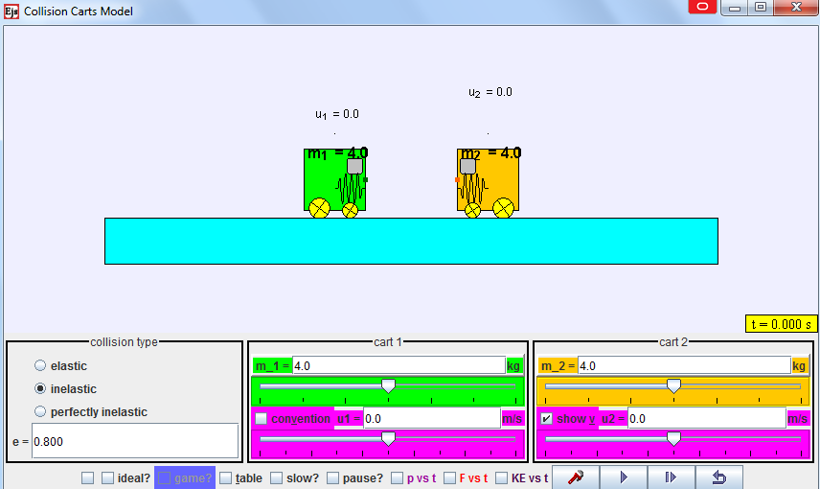
- This simulation is also known as ‘Collision Cart Model’, as it allows users to observe and explore the velocities and forces acting on two carts undergoing different types of collisions, namely elastic, inelastic or perfectly inelastic collision.
- Starting with the “Collision type”, click on the type of collision for analysis. “e” is known as the coefficient of restitution, which is also the ratio of speeds after and before an impact.
- For “Cart 1”, check so that the velocity arrows can point according to sign convention of “Pointing to right as positive” and “Pointing to left as negative”. Adjust the mass of cart 1, m₁ and its initial velocity u₁, by keying in the values and press ‘Enter’, or adjusting the sliders.
- For “Cart 2”, make sure is checked so that the velocity arrows are visible. Adjust the mass of cart 2, m₂ and its initial velocity u₂, by keying in the values and press ‘Enter’, or adjusting the sliders.
- Once you are ready, click to start the motion of the carts according to your settings.
- To slow down the motion, you may click to pause the motion and click to move the cart by a small time interval repeatedly.
- Get yourself familiarised with the simulation by trying out a few settings for the next 5 minutes. Once you are ready, proceed to the next section.

B Understanding the three different types of collisions (30 min)
Now that you are familiar with the simulation, use it to explore the following collisions and help you:
- Sketch the carts & indicate the direction and magnitude of their velocities after the collision.
- Fill in the respective values in the tables provided.
- ELASTIC collision

Trolley B
(4 kg)
2.0 m s⁻¹
0.0 m s⁻¹
Trolley A
(4 kg)
Trolley B
(4 kg)
2.0 m s⁻¹
0.0 m s⁻¹
Trolley A
(4 kg)

[Before ELASTIC collision]
[After ELASTIC collision]

Before collision |  |  |  | After collision
Momentum of trolley A/ kg m s⁻¹ | Momentum of trolley B/ kg m s⁻¹ | Total momentum of trolleys A & B/ kg m s⁻¹ |  | Momentum of trolley A/ kg m s⁻¹ | Momentum of trolley B/ kg m s⁻¹ | Total momentum of trolleys A & B/ kg m s⁻¹ | Is there C.O.M.?
8.00 | 0.00 | 8.00 |  | 0.00 | 8.00 | 8.00 | Yes
Before collision |  |  |  | After collision
Kinetic energy of trolley A/ J | Kinetic energy of trolley B/ J |  | Total kinetic energy of trolleys A & B/ J | Kinetic energy of trolley A/ J | Kinetic energy of trolley B/ J | Total kinetic energy of trolleys A & B/ J | Is there C.O.K.E.?
8.00 | 0.00 |  | 8.00 | 0.00 | 8.00 | 8.00 | Yes
C.O.M. refers to Conservation Of Momentum
C.O.K.E. refers to Conservation Of Kinetic Energy

Suggest a real life example of an ELASTIC collision:
Two magnets of the same pole facing each other on frictionless carts and one of them is moving towards another which was at rest.
_________________________________________________________________________
_________________________________________________________________________

  - INELASTIC collision
Trolley A
(4 kg)
Trolley B
(4 kg)
1.176 m s⁻¹
0.824 m s⁻¹
2.0 m s⁻¹
0.0 m s⁻¹
Trolley B
(4 kg)
Trolley A
(4 kg)
[Before INELASTIC collision]
[After INELASTIC collision]

Before collision |  |  |  | After collision
Momentum of trolley A/ kg m s⁻¹ | Momentum of trolley B/ kg m s⁻¹ | Total momentum of trolleys A & B/ kg m s⁻¹ |  | Momentum of trolley A/ kg m s⁻¹ | Momentum of trolley B/ kg m s⁻¹ | Total momentum of trolleys A & B/ kg m s⁻¹ | Is there C.O.M.?
8.00 | 0.00 | 8.00 |  | 3.29 | 4.71 | 8.00 | Yes
Before collision |  |  |  | After collision
Kinetic energy of trolley A/ J | Kinetic energy of trolley B/ J |  | Total kinetic energy of trolleys A & B/ J | Kinetic energy of trolley A/ J | Kinetic energy of trolley B/ J | Total kinetic energy of trolleys A & B/ J | Is there C.O.K.E.?
8.00 | 0.00 |  | 8.00 | 1.36 | 2.77 | 4.12 | No
C.O.M. refers to Conservation Of Momentum
C.O.K.E. refers to Conservation Of Kinetic Energy

Suggest a real life example of an INELASTIC collision:
A moving car collides onto a stationary car waiting at the cross junction.
_________________________________________________________________________
_________________________________________________________________________

- PERFECTLY INELASTIC collision
2.0 m s⁻¹
0.0 m s⁻¹
1.00 m s⁻¹
Trolley B
(4 kg)
Trolley A
(4 kg)
Trolley A
(4 kg)
Trolley B
(4 kg)
[Before PERFECTLY INELASTIC collision]
[After PERFECTLY INELASTIC collision]

Before collision |  |  |  | After collision
Momentum of trolley A/ kg m s⁻¹ | Momentum of trolley B/ kg m s⁻¹ | Total momentum of trolleys A & B/ kg m s⁻¹ |  | Momentum of trolley A/ kg m s⁻¹ | Momentum of trolley B/ kg m s⁻¹ | Total momentum of trolleys A & B/ kg m s⁻¹ | Is there C.O.M.?
8.00 | 0.00 | 8.00 |  | 4.00 | 4.00 | 8.00 | Yes
Before collision |  |  |  | After collision
Kinetic energy of trolley A/ J | Kinetic energy of trolley B/ J |  | Total kinetic energy of trolleys A & B/ J | Kinetic energy of trolley A/ J | Kinetic energy of trolley B/ J | Total kinetic energy of trolleys A & B/ J | Is there C.O.K.E.?
8.00 | 0.00 |  | 8.00 | 2.00 | 2.00 | 4.00 | No
C.O.M. refers to Conservation Of Momentum
C.O.K.E. refers to Conservation Of Kinetic Energy

Suggest a real life example of a PERFECTLY INELASTIC collision:
A wrestler runs towards his stationary opponent and grabs him by the waist.
_________________________________________________________________________
___________________________________________________________________

Conclusion:
Types of collision | C.O.M.?  Yes Yes  Yes No  Yes No | C.O.K.E?
ELASTIC
INELASTIC
PERFECTLY INELASTIC

C Understanding more about Newton’s third law and C.O.M. (30 min)
- Take note that the simulation ignores the effect of friction by the ground or air resistance, and the ground is perfectly horizontal.
- Refer to the above ELASTIC collision again and set the mass and initial velocities of both carts to the same values.
- Click “slow?”, “p vs t” and “F vs t” as shown below, so that (i) the motion will slow down during the interaction of the two carts; (ii) a graph of momentum against time and (iii) a graph of force against time will appear. Also click “Cart 1”, “Cart 2” and “Total” to display the graphs of cart 1, cart 2 and the total system.



- Click to observe the forces acting on each cart during the interaction and the graphs plotted.

F vs t graph
- Sketch the graphs of force against time for (i) “cart 1”; (ii) “cart 2”; (iii) “total” in the same axes below and label the three graphs clearly (if possible, use 3 different ink colours for “cart 1”, “cart 2” and “total”).
Force / N
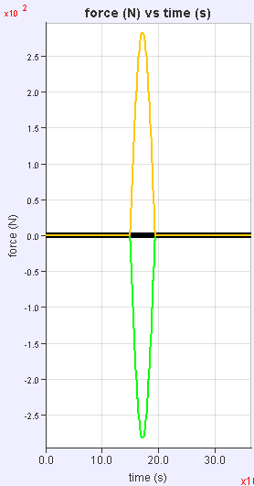

Time / s

- Did cart 1 exert a constant force on cart 2, and vice versa, throughout the interaction? If not, describe how the magnitude of force varies with time.
No, the force is not constant. The magnitude increases to a peak and reduces back to zero.
_________________________________________________________________________
_________________________________________________________________________
- What did you notice about the magnitude and direction of the forces acting on each cart?
The magnitudes of the forces are always the same but the directions are always opposite.
_________________________________________________________________________
- What do we usually call these pairs of forces, according to Newton’s 3rd law?
Action-reaction pairs
_________________________________________________________________________
- What did you notice about the total force acting on the system (which consists of the two carts)?
The total force is always zero, even when the individual forces are not zero.
_________________________________________________________________________
p vs t graph
- Sketch the graphs of momentum against time for (i) “cart 1”; (ii) “cart 2”; (iii) “total” in the same axes below and label the three graphs clearly. (if possible, use the same 3 different colours for “cart 1”, “cart 2” and “total”)
Momentum, p / kg m s⁻¹
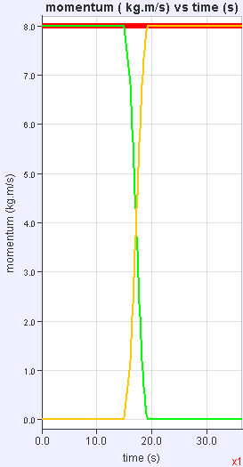

Time / s

- Did the momentum of cart 1 remains constant? How about the momentum of cart 2?
No, neither the momentum of cart 1 nor the momentum of cart 2 remains constant.
_________________________________________________________________________
- What did you notice about the total momentum of the system (which consists of the two carts)?
The total momentum of the system remains constant.
_________________________________________________________________________
- Did the individual forces acting on each cart by the other cart affect the total momentum of the system? Explain your answer.
No, the forces acting on each cart are always equal in magnitude and opposite in direction. Hence resultant force acting on the system is always zero which results in no change in total momentum.
_________________________________________________________________________
_________________________________________________________________________
_________________________________________________________________________
- Link your answer in Q13 to your previous table of momentum for ELASTIC collision and the concept of Conservation of Momentum (C.O.M.).
Is C.O.M. referring to the momentum of cart 1, cart 2 or the total momentum? Explain your answer.
C.O.M. is referring to the conservation of total momentum, as the system of the two carts is a closed system where resultant force is zero. Not the individual cart.
_________________________________________________________________________
___________________________________________________________________
- Mark a point on the p vs t graph to show the instant when the two carts are closest to each other.

KE vs t graph (Predict-Observe-Explain)
- Based on the “p vs t” graph sketched earlier, predict how the “KE vs t” graphs of cart 1, cart 2 and total KE vs t graph will look like and sketch your prediction below. Label the three graphs clearly.
Kinetic energy / J

Prediction

Time / s

- Click “KE vs t” as shown below, so that a graph of kinetic energy against time will appear.
Sketch the graphs of kinetic energy against time for (i) “cart 1”; (ii) “cart 2”; (iii) “total” in the same axes below and label the three graphs clearly. (if possible, use the same 3 different colours for “cart 1”, “cart 2” and “total”)
Kinetic energy / J
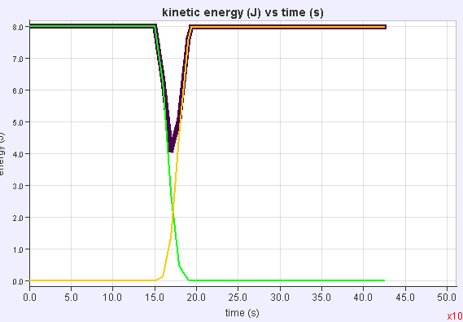
Time / s
Actual

- Compare the actual KE vs t graphs with your prediction and reflect why they are different (if they are different).
- Since kinetic energy is conserved in Elastic Collision, suggest why there is a drop in the total kinetic energy during the collision.
Some of the total kinetic energy is converted to potential energy in the carts when the carts collided, before converting back to kinetic energy when the carts separated.
_________________________________________________________________________
_________________________________________________________________________

D Exploring the concepts further on your own (if time permits)
- Predict how the F vs t graphs and p vs t graphs for INELASTIC collision and PERFECTLY INELASTIC collision will look like. Check your predictions using the simulation.
- Describe the motion of the carts at the instant when their p vs t graphs intersect.
- What happens to all the graphs if the masses of the two carts are different?
~ Please complete a survey @ https://sites.google.com/site/lookang/collision-carts-dynamics-ajc ~

[For teachers: You may use the analysis tool to demonstrate to students that the area under the F vs t graph is equal to the change in momentum.]

--- End of worksheet ---

